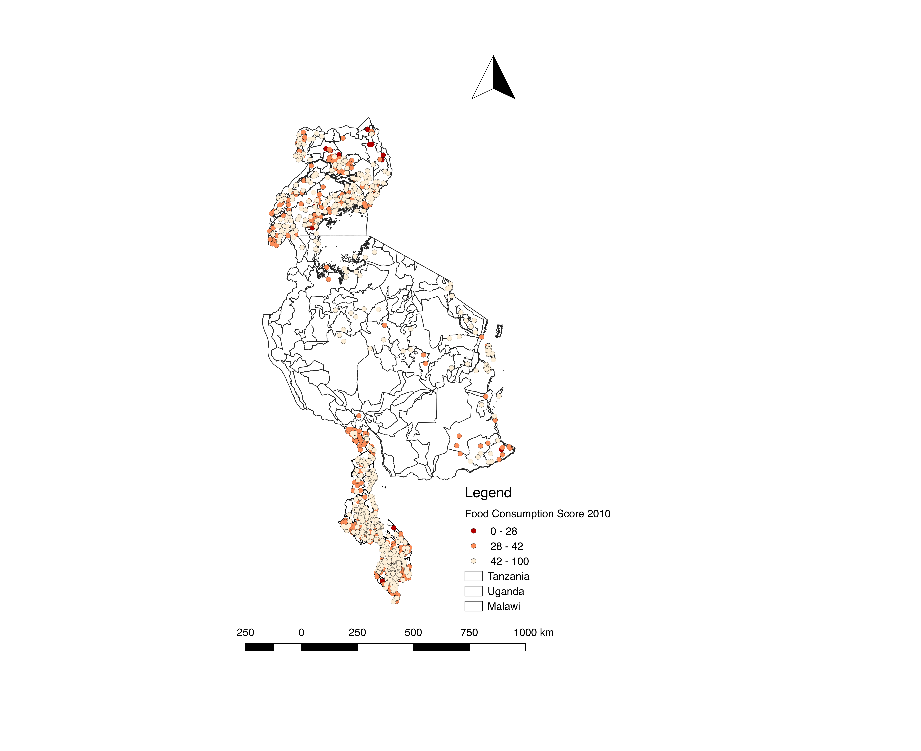

**Figure 1 Map of FCS in 2010**



**Figure 2: ROC curves** **of Baseline vs. ML algorithms (most food secure category versus the rest)**



**Figure 3 ROC curves of Baseline vs. ML algorithms (most food insecure category versus the rest)**



**Figure 4. ROC curves with different sampling methods (most food insecure category versus the rest)** **Figure 5. ROC curves for classifying the 20 percent food insecure category**

**Table 1: ML algorithm V.S. baseline results with most food secure category versus the rest** **categorization**

|  |  |  |  |  |  |  |  |  |
| --- | --- | --- | --- | --- | --- | --- | --- | --- |
| Country | Food Security Measure | Threshold | Recall  (Base  line) | Recall  (ML) | F-1 score  (Base  line) | F-1 score (ML) | Accuracy  (Baseline) | Accuracy  (ML) |
| Malawi | FCS | 0.50 | 0.38 | 0.55 - 0.89 | 0.47 | 0.66-0.75 | 0.55 | 0.52-0.69 |
| rCSI | 0.40 | 0.60 | 0.76 - 0.96 | 0.71 | 0.83-0.94 | 0.58 | 0.76-0.96 |
| Tanzania | FCS | 0.30 | 0.11 | 0.78 – 1.00 | 0.14 | 0.22-0.50 | 0.84 | 0.12-0.84 |
| rCSI | 0.30 | 0.44 | 0.72-1.00 | 0.46 | 0.56-0.57 | 0.59 | 0.40-0.59 |
| Uganda | FCS | 0.50 | 1.00 | 0.57-1.00 | 0.39 | 0.39-0.48 | 0.25 | 0.24-0.70 |

**\*** ML results shown in range as the performance of the three models vary slightly

**Table 2: ML algorithm V.S. baseline results with most food insecure category versus the rest categorization**

|  |  |  |  |  |  |  |  |  |
| --- | --- | --- | --- | --- | --- | --- | --- | --- |
| Country | Food Security Measure | Threshold | Recall  (Baseline) | Recall  (ML) | Recall  (ML+  sampling) | F-1 score  (Baseline) | F-1 score (ML) | F-1 score  (ML+  Sampling) |
| Malawi | FCS | 0.01 | 0.36 | 0.73-1.00 | 0.82-0.91 | 0.04 | 0.03-0.06 | 0.03–0.06 |
| rCSI | 0.01 | 0.34 | 0.00-0.85 | 0.15-0.25 | 0.16 | 0.03-0.16 | 0.12-0.17 |
| Tanzania | FCS | 0.01 | 0.00 | 1.00-1.00 | 1.00-1.00 | 0.00 | 0.01-0.04 | 0.01-0.04 |
| rCSI | 0.01 | 0.00 | 0.80-1.00 | 1.00-1.00 | 0.00 | 0.03-0.06 | 0.03-0.03 |
| Uganda | FCS | 0.08 | 0.00 | 0.00-1 | 0.86-0.86 | 0.00 | 0.00-0.30 | 0.19-0.32 |

* ML results shown in range as the performance of the three models vary slightly

**Table 3: error analysis based on a binary cutoff (most food insecure category versus the rest)**

|  |  |  |  |  |  |
| --- | --- | --- | --- | --- | --- |
| Country | Food Security Measure | Percent of False Negative  (%) | Magnitude of misclassification  (average % off from the cut-off) | Percent of False Positive  (%) | Magnitude of misclassification  (average % off from the cut-off) |
| Malawi | FCS | 0.13 | 6.47 | 54.6 | 42.67 |
| rCSI | 6.91 | 27.13 | 4.73 | 69.72 |
| Tanzania | FCS | 0 | NA | 21.15 | 86.21 |
| rCSI | 0.32 | 33.04 | 20.51 | 77.41 |
| Uganda | FCS | 0 | NA | 47.3 | 66.56 |

**Table 4: ML algorithm V.S. baseline results (more than twenty percent food insecure households versus the rest)**

|  |  |  |  |  |  |  |
| --- | --- | --- | --- | --- | --- | --- |
| Country | Food Security Measure | Threshold | Recall  (Baseline) | Recall  (ML) | F-1 score  (Baseline) | F-1 score (ML) |
| Malawi | FCS | 0.14 | 0.53 | 0.68-0.93 | 0.41 | 0.52-0.56 |
| rCSI | 0.01 | 0.01 | 0.88-0.94 | 0.50 | 0.56-0.62 |
| Tanzania | FCS | 0.04 | 0.04 | 0.84-1.00 | 0.22 | 0.26-0.39 |
| rCSI | 0.05 | 0.05 | 0.75-1.00 | 0.31 | 0.29-0.57 |
| Uganda | FCS | 0.24 | 0.23 | 0.58-0.80 | 0.13 | 0.36-0.39 |

**Table 5: Random Forests Feature importance of variables in Malawi-FCS**

|  |  |  |  |
| --- | --- | --- | --- |
| **Variable**  **(original)** | **Importance** | **Variable (oversample)** | **Importance** |
| Number cellphones | 0.12 | Natural roof | 0.11 |
| Own a cell phone | 0.09 | Own a Cell phone | 0.09 |
| Natural roof | 0.05 | Floor dirt sand | 0.08 |
| Asset index | 0.04 | Number cellphones | 0.05 |
| Month | 0.04 | Iron Roof | 0.04 |
| Floor dirt sand | 0.03 | First day of rain | 0.04 |
| Distance to population center | 0.03 | Bean price | 0.04 |
| Distance to road | 0.03 | Max days without rain | 0.03 |
| Percent of agricultural land | 0.03 | Nuts market thinness | 0.03 |
| Max days without rain | 0.03 | Asset index | 0.03 |
| Bean price | 0.03 | Household head age | 0.03 |
| Distance to ADMARC markets | 0.03 | Maize price | 0.03 |
| Rain in flood region | 0.02 | Distance to the nearest road | 0.03 |

**Appendix:**

**Table A1: Food security categories of cluster means VS percent of households in low or mid category**

|  |  |  |
| --- | --- | --- |
| **Category of cluster mean** | **% of HH in medium or low category** | **% of HH in low category** |
| Malawi-FCS | | |
| High | 0.43 | 0.11 |
| Medium | 0.68 | 0.25 |
| Low | 0.91 | 0.65 |
| Malawi-rCSI | | |
| High | 0.25 | 0.07 |
| Medium | 0.42 | 0.13 |
| Low | 0.72 | 0.35 |
| Tanzania-FCS | | |
| High | 0.40 | 0.13 |
| Medium | 0.59 | 0.22 |
| Low | 0.68 | 0.37 |
| Tanzania-rCSI | | |
| High | 0.26 | 0.10 |
| Medium | 0.38 | 0.16 |
| Low | 0.48 | 0.25 |
| Uganda-FCS | | |
| High | 0.47 | 0.19 |
| Medium | 0.68 | 0.26 |
| Low | 0.76 | 0.51 |

**Table A2: Variable list and summary statistics (TBD)**

**Table A3. Results of the percentage of households in the middle and most food insecure category**

|  |  |  |  |  |
| --- | --- | --- | --- | --- |
| Country | Measure | Model | R squared | |
|  |  |  | Percent of most food insecure | Percent of middle and most food insecure |
| Malawi | FCS | Linear Regression | 0 | 0.008 |
| Malawi | rCSI | Linear Regression | 0.001 | 0 |
| Tanzania | FCS | Linear Regression | 0.116 | 0.205 |
| Tanzania | rCSI | Linear Regression | 0.085 | 0.082 |
| Uganda | FCS | Linear Regression | 0.037 | 0.121 |
| Malawi | FCS | LASSO | 0.081 | 0.138 |
| Malawi | rCSI | LASSO | 0.016 | 0.033 |
| Tanzania | FCS | LASSO | 0.117 | 0.237 |
| Tanzania | rCSI | LASSO | 0.031 | 0.094 |
| Uganda | FCS | LASSO | 0.046 | 0.138 |
| Malawi | FCS | ElasticNet | 0.086 | 0.128 |
| Malawi | rCSI | ElasticNet | 0.016 | 0.032 |
| Tanzania | FCS | ElasticNet | 0.113 | 0.25 |
| Tanzania | rCSI | ElasticNet | 0.031 | 0.086 |
| Uganda | FCS | ElasticNet | 0.045 | 0.169 |
| Malawi | FCS | Random Forest | 0.217 | 0.536 |
| Malawi | rCSI | Random Forest | 0.128 | 0.196 |
| Tanzania | FCS | Random Forest | 0.176 | 0.287 |
| Tanzania | rCSI | Random Forest | 0.07 | 0.084 |
| Uganda | FCS | Random Forest | 0.178 | 0.276 |

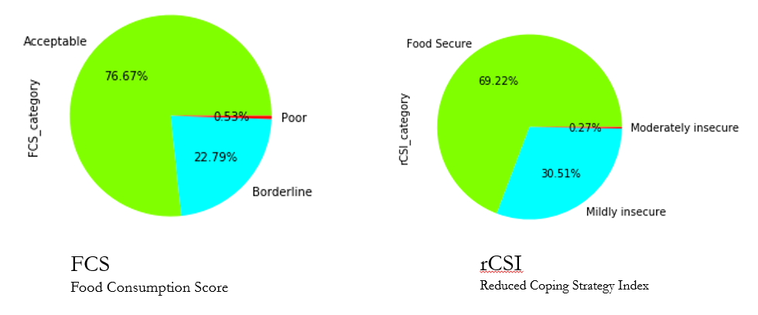

**Figure A1. Pie chart of food security categories**



**Figure A2. Precision-Recall curves of Baseline vs. ML algorithms (most food secure VS not)**



**Figure A3. Precision-Recall curves of Baseline vs. ML algorithms (most food insecure VS not)**



**Figure A4. Precision-Recall curves of Baseline vs. ML algorithms (with 20 percent food insecure households VS not)**



**Figure A5. Precision-Recall curves with different sampling methods (most food insecure category VS rest)**